Grazioso Salvare Dashboard
Stevie Chryn
23-Feb-25

Project Overview
This dashboard was made to visualize animal shelter data interactively from Grazioso Salvare. This dashboard allows filtering, graphing, and geolocation mapping of shelter animals. The project is built using Python and the JupyterDash framework.

Functionality
The dashboard includes the following features:
- Data Retrieval: Connects to a MongoDB database and fetches real-time animal shelter data.
- Interactive Filtering: Allows users to filter animals by type (Dogs, Cats, Other).
- Data Table: Displays detailed animal records with sorting, filtering, and selection capabilities.
- Breed Distribution Chart: A pie chart visualizing the distribution of animal breeds.
- Geolocation Mapping: Displays the selected animal's location on a map.

Screenshots / Proof of Functionality
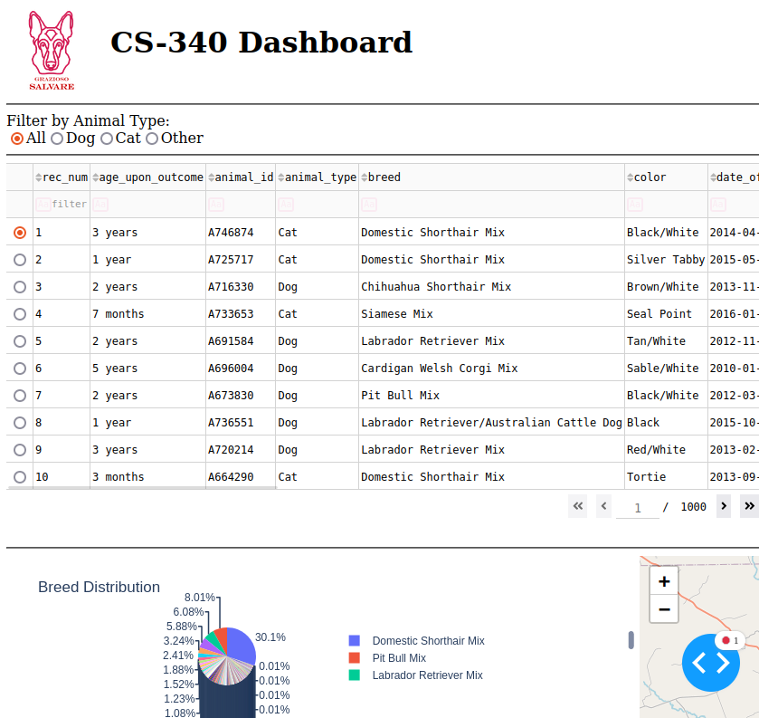

Tools & Technologies Used

MongoDB
MongoDB was used as the backend database due to its NoSQL and scalability:
- NoSQL document structure, making it easy to interface with Python using the pymongo library.
- Scalability, supporting large datasets without predefined schemas.

JupyterDash Framework
JupyterDash, built on top of Flask and Plotly, was used to develop the dashboard:
- Built-in interactive components like tables, charts, and maps.
- Pythonic, making it have seamless integration with data processing libraries like numpy.

Additional Libraries
- Pandas: For data manipulation and transformation.
- dash_leaflet: For rendering interactive maps.
- plotly.express: For generating the breed distribution pie chart.
- Base64: For embedding the Grazioso Salvare logo in the dashboard.

Project Steps
- Set Up the Database: Connected to MongoDB and retrieved data using the read method.
- Data Cleaning: Removed unnecessary fields like _id to prevent compiling issues.
- Dashboard Layout:
  - Implemented filtering options (radio buttons).
  - Integrated a data table for record display.
  - Created a pie chart to visualize breed distribution.
  - Integrated a map for geolocation visualization.
- Implemented Callbacks:
  - Updated the table based on selected filters.
  - Rendered the pie chart dynamically.
  - Displayed the correct animal location when an entry was selected.
- Tested and Debugged: Verified functionality and resolved UI/logic issues.
- Finalized UI: Adjusted layout for better alignment and usability.

Challenges & Solutions

1. Data Table Crashes Due to _id
Issue: MongoDB _id fields caused issues when rendering in Dash tables.
Solution: Used df.drop(columns=['_id'], inplace=True) to remove it before display.

2. Image Embedding
Issue: Grazioso Salvare’s logo was not displaying correctly.
Solution: I realized I didn’t put the decode() function in before placing the image in the src.

3. Server Environment
Issue: Somehow my remote environment broke, and MongoSH as well as firefox wouldn’t open.
Solution: The environment had to be force reset due to a ghost instance running which was not tied to any browser.

Resources
- MongoDB Documentation
- Dash Leaflet

Reproducing the Project

Prerequisites
- Install Python 3.9+.
- Install the required Python packages:
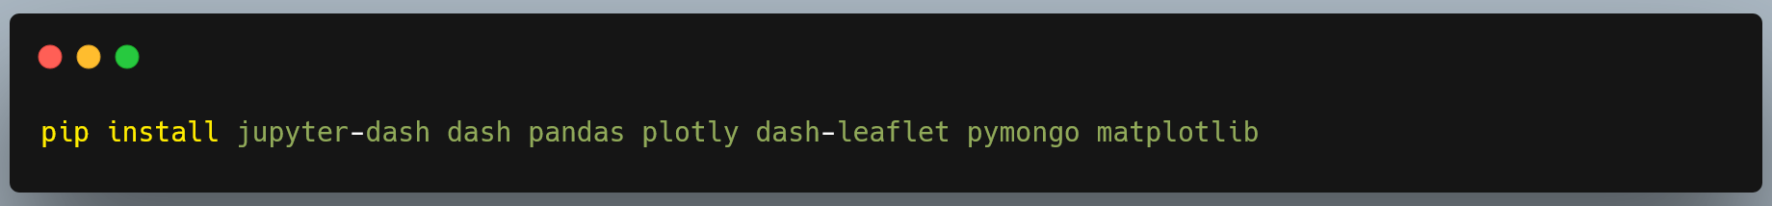
- Make sure MongoDB is running and accessible.

